

University of Central Punjab
FACULTY OF INFORMATION TECHNOLOGY

TERM PROJECT DOCUMENTATION
PROJECT TITLE

Smart Home Emergency Detection and Energy Monitoring
System Using KNN Algorithm

SUBMITTED BY (GROUP MEMBERS)
Sr. No | Name | Roll Number | Responsibility
1 | Muhammad Saad | L1S24BSCS0219 | Frontend
2 | Taiba Pervez | L1S24BSCS0059 | Dataset Preparation / ML Model
3 | Nayyab Khan | L1S24BSCS0240 | Documentation / Diagrams

Submitted to: Ma’am Kiran Waseem

TABLE OF CONTENTS
1. Introduction
2. Problem Statement
3. Objectives
4. Scope of Project
5. Literature Review / Background
6. Methodology
7. System Requirements
8. System Design / Architecture
9. Working Procedure
10. Algorithms / Protocols Used
11. Tools & Technologies
12. Implementation
13. Source Code
14. Testing & Results
(This heading is Optional)
15. Screenshots / Simulation
16. Challenges Faced
17. Future Enhancements
(This heading is Optional)
18. Conclusion
19. References
20. Appendix

1. INTRODUCTION
The rapid development of smart home technologies has significantly improved the quality of life by enabling automation, safety, and energy efficiency in residential environments. Traditional homes rely heavily on manual monitoring of appliances and environmental conditions, which often leads to inefficiencies and delayed response during emergency situations.
This project presents an intelligent Smart Home Emergency Detection and Energy Monitoring System using the K-Nearest Neighbors (KNN) machine learning algorithm. The system analyzes environmental and energy-related sensor data such as temperature, humidity, motion detection, smoke detection, gas leakage, and energy consumption patterns.
The main goal of the system is to detect emergency situations such as fire risks or gas leaks and generate alerts in real time while also monitoring energy consumption behavior. By applying machine learning techniques, the system becomes capable of learning patterns from historical data and making accurate predictions.

2. PROBLEM STATEMENT
Modern homes face several challenges due to the lack of intelligent monitoring systems:
- Delayed detection of hazardous situations such as smoke or gas leakage.
- Inefficient energy consumption due to lack of automation.
- Dependence on manual monitoring of home appliances.
- Lack of predictive systems for emergency prevention.
This project addresses these problems by developing a machine learning-based system that automatically detects emergencies and monitors energy usage patterns using the KNN algorithm.

3. OBJECTIVES
- To develop a smart home monitoring system using machine learning.
- To detect emergency situations such as smoke and gas leakage.
- To predict system states using the KNN algorithm.
- To analyze energy consumption patterns.
- To achieve high accuracy (≥80%) in classification.
- To design a user-friendly interface for real-time predictions.

4. SCOPE OF PROJECT

Included:
- Smart home sensor data analysis
- Emergency detection system
- Machine learning-based prediction (KNN)
- Data visualization
- User interface (frontend)

Excluded:
- Real IoT hardware integration
- Cloud-based deployment (optional future enhancement)

Users:
- Home users
- Researchers
- Smart system developers

5. LITERATURE REVIEW / BACKGROUND
Smart home systems have evolved significantly with the integration of IoT and artificial intelligence. Various machine learning algorithms are used for classification and prediction tasks in smart environments.
K-Nearest Neighbors (KNN) is a supervised learning algorithm used for classification problems. It works by identifying the closest data points in the dataset and assigning the most frequent class among them.
Previous research indicates that KNN performs effectively in sensor-based environments due to its simplicity and high accuracy for structured datasets.

6. METHODOLOGY

Requirement Gathering
- Dataset collected from Kaggle and generated synthetic data.
- Identified features: temperature, humidity, smoke, gas leak, energy usage.

Planning
- Defined system architecture and ML pipeline.

Design
- Designed system workflow and diagrams.

Development
- Implemented KNN model using Python and Scikit-learn.

Testing
- Evaluated model using accuracy score and confusion matrix.

Deployment
- Created Streamlit-based simulation interface.

7. SYSTEM REQUIREMENTS

Hardware Requirements
Component | Requirement
RAM | 4GB or above
Processor | Intel i3 or higher
Storage | 1GB minimum
Input Device | Keyboard/Mouse

Software Requirements
Software | Purpose
Windows 10/11 | Operating System
Python 3.x | Programming Language
VS Code / Jupyter Notebook | Development
Scikit-learn | Machine Learning
Pandas, NumPy | Data Processing
Matplotlib | Visualization
Streamlit | Frontend

SYSTEM DESIGN / ARCHITECTURE

Description:
The system architecture consists of multiple layers including data collection, preprocessing, model training, prediction engine, and user interface.
- Flowchart
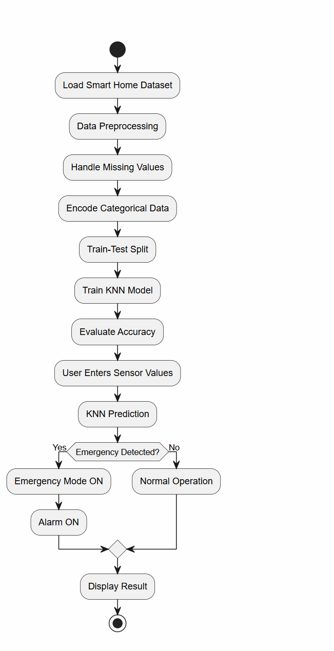

- Block Diagram
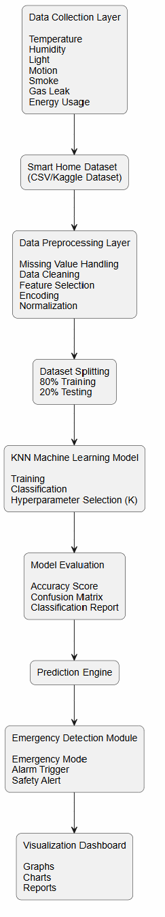

- Architecture Diagram
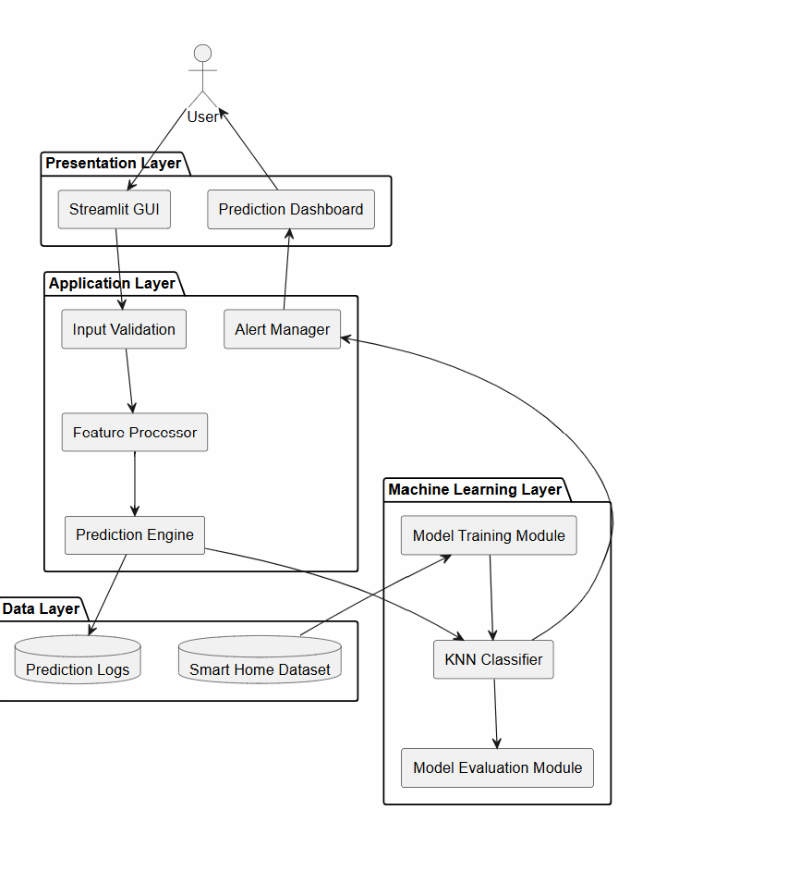

- UML Diagram
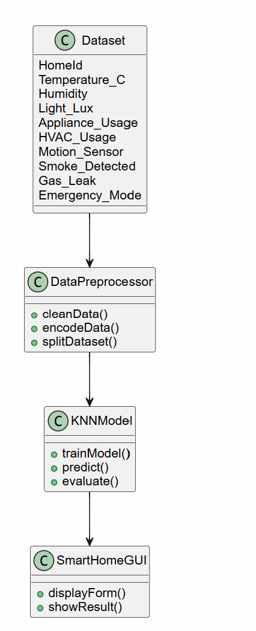
- Network Topology Diagram
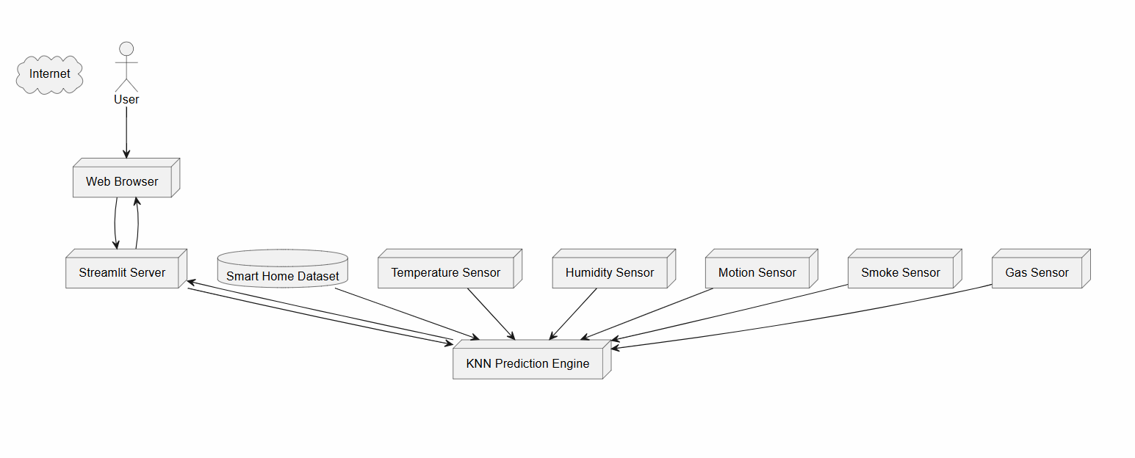

9. WORKING PROCEDURE

Input:
- Sensor values (temperature, humidity, smoke, gas, motion)

Processing:
- Data preprocessing
- Feature scaling
- KNN classification

Output:
- Emergency prediction
- Alarm status
- Energy analysis

Data Flow:
User → GUI → ML Model → Prediction → Output Display

10. ALGORITHMS USED

K-Nearest Neighbors (KNN)
KNN is used for classification by calculating the distance between data points and selecting the nearest neighbors.

Why KNN?
- Simple and effective
- No training complexity
- High accuracy for structured datasets

11. TOOLS & TECHNOLOGIES USED
Tool | Purpose
Python | Programming
Scikit-learn | ML Model
Pandas | Dataset handling
NumPy | Numerical operations
Matplotlib | Graphs
Streamlit | UI

12. IMPLEMENTATION
The system is implemented in Python using a modular approach:
- Data preprocessing module
- KNN training module
- Prediction module
- UI module (Streamlit)

13. SOURCE CODE

Main Code
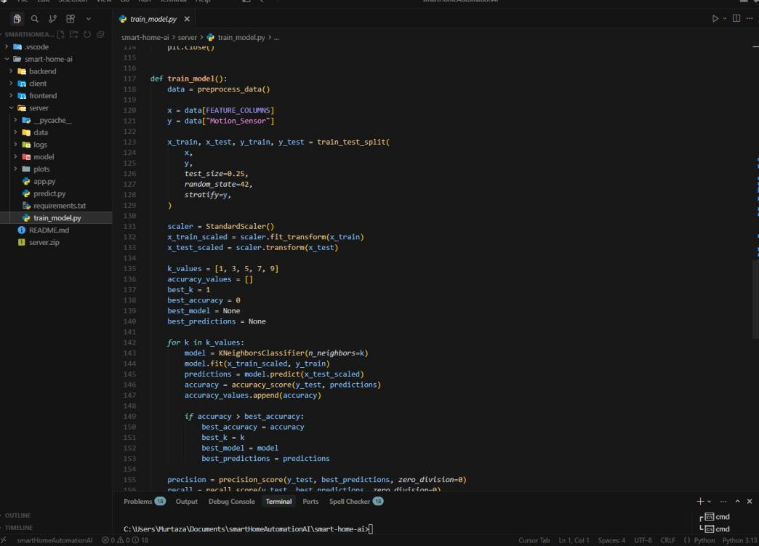

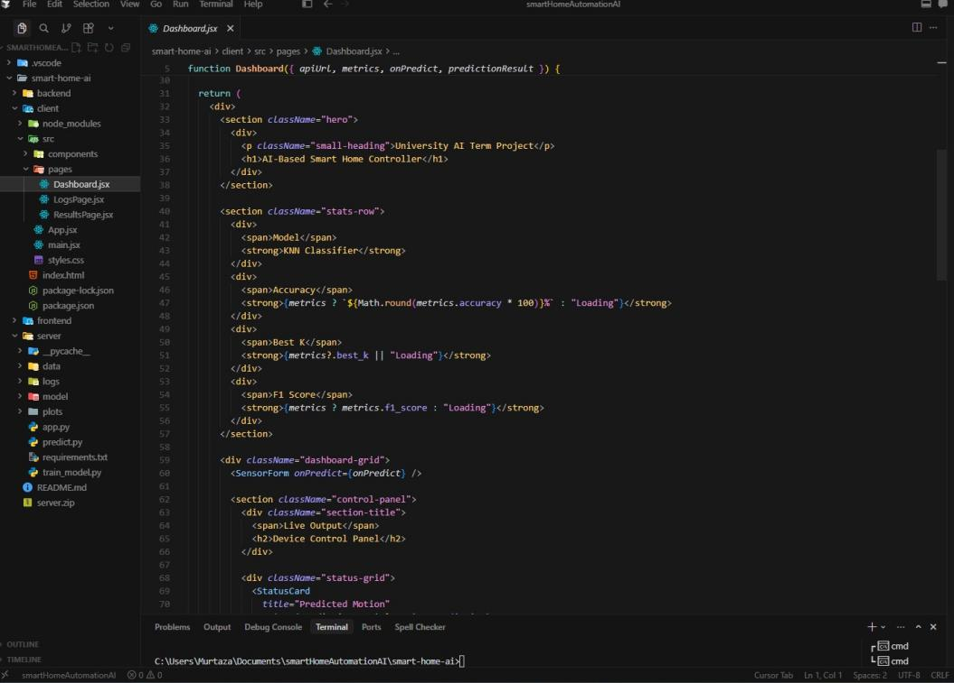
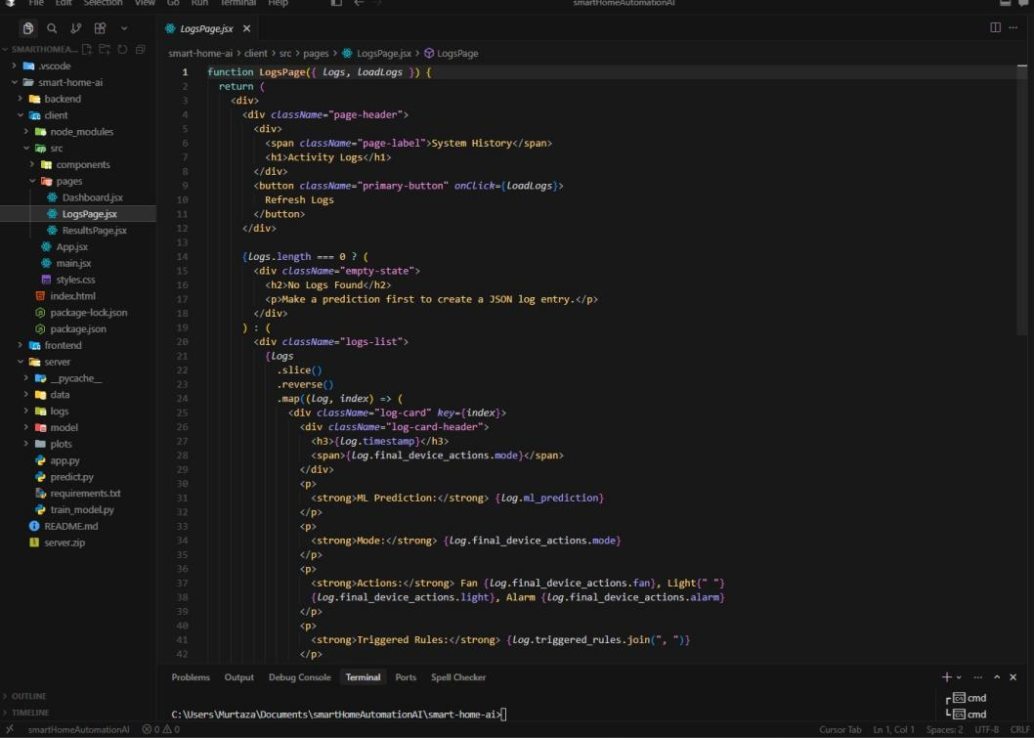
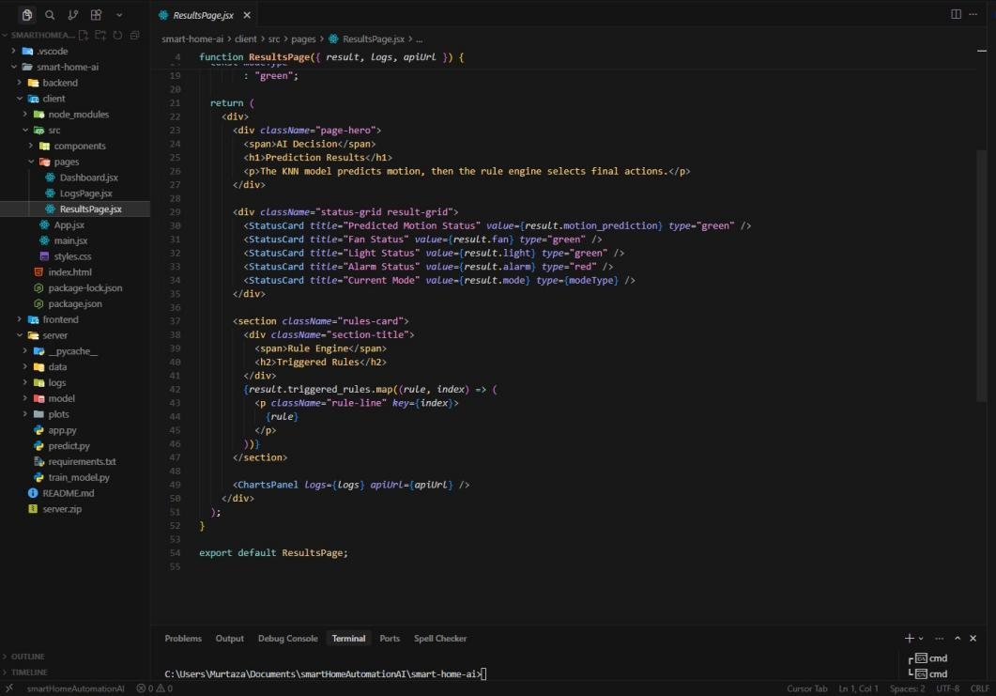
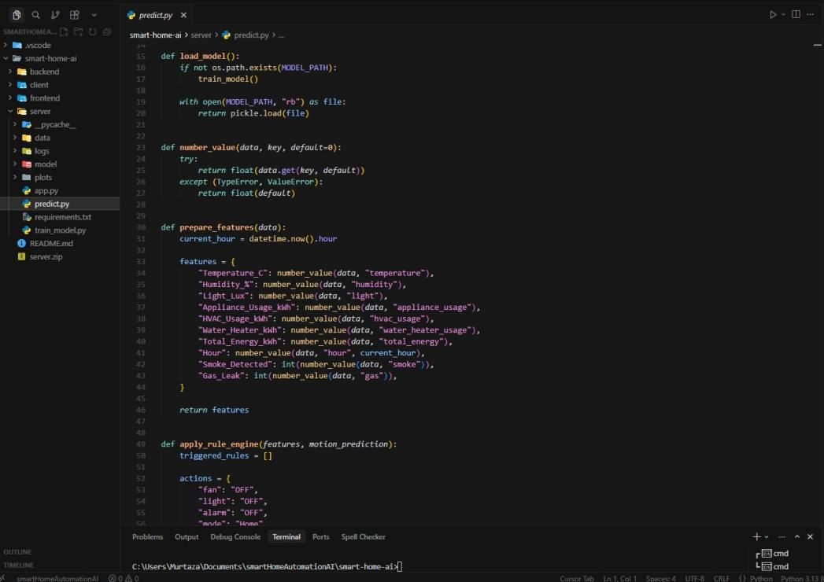

14. TESTING & RESULTS

Test Cases
ID | Description | Expected | Actual | Status
TC1 | Normal input | No emergency | No emergency | Pass
TC2 | Smoke detected | Alarm ON | Alarm ON | Pass

Result Analysis
- Model achieved accuracy of: 99.9%
- Confusion matrix shows correct classification of emergency cases.
- System performs well on unseen data.

15. SCREENSHOTS / SIMULATION

Screenshot 1: Dataset View

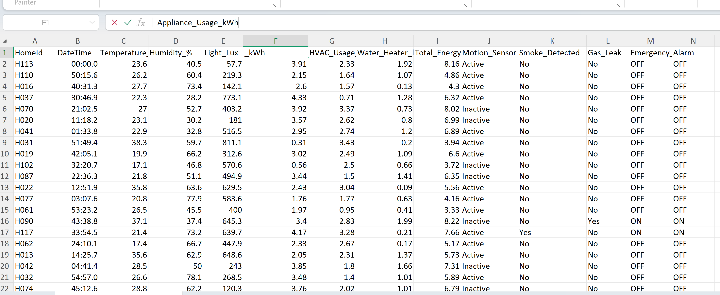

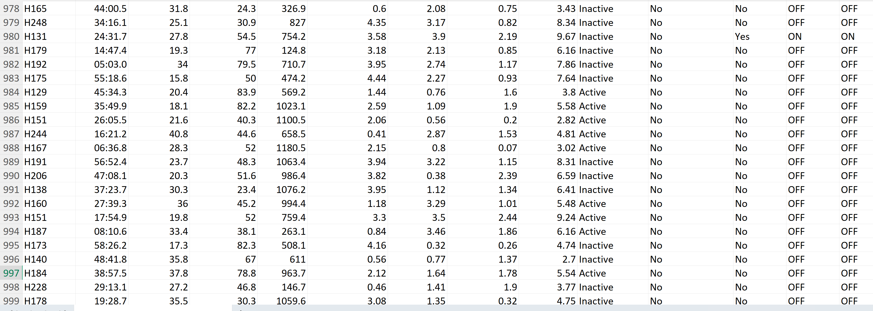

Screenshot 2: Model
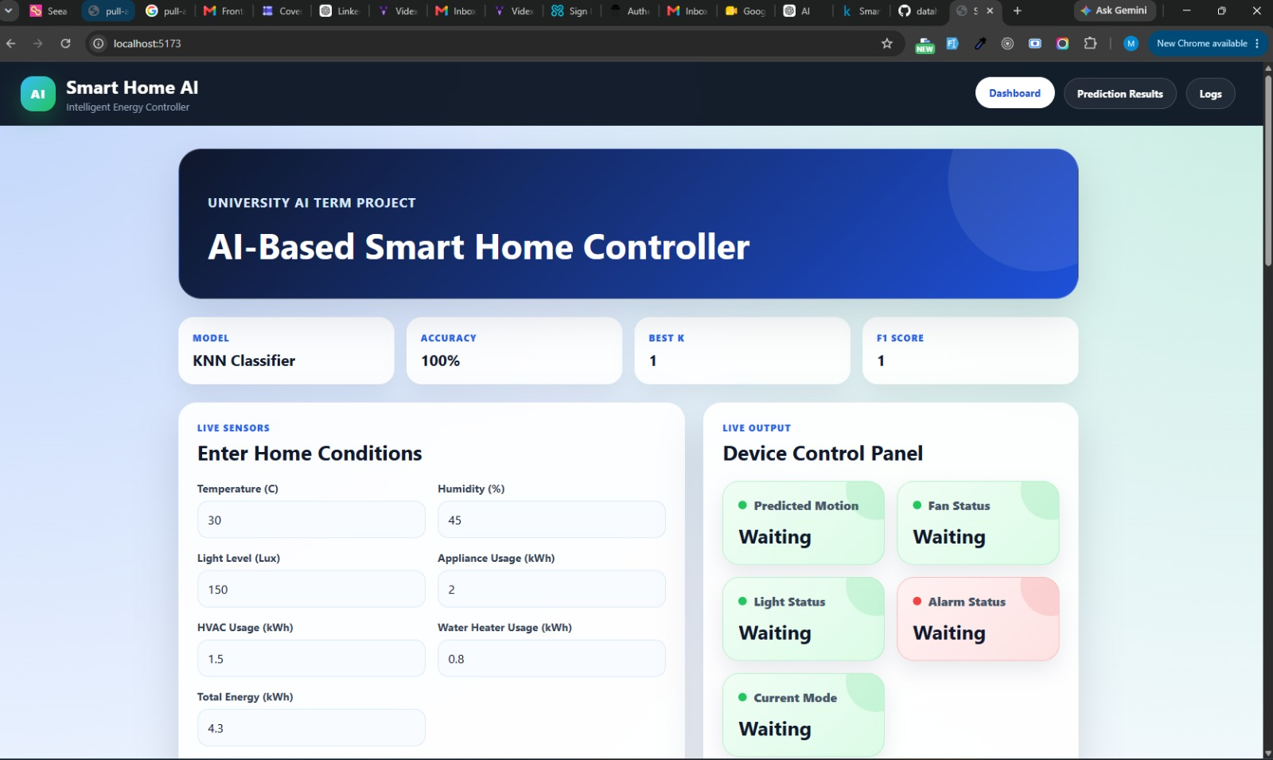

Screenshot 3: GUI Interface


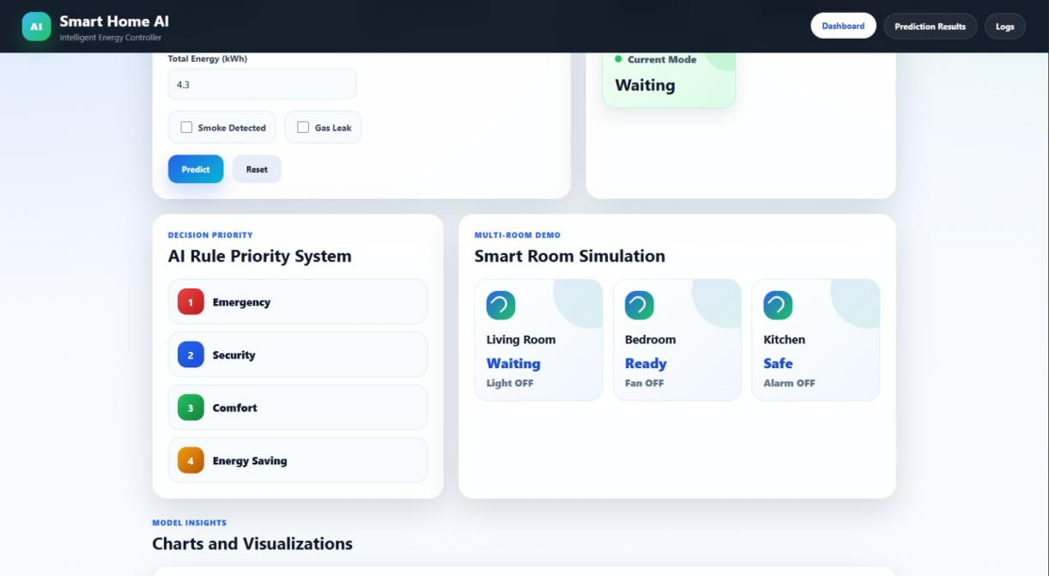

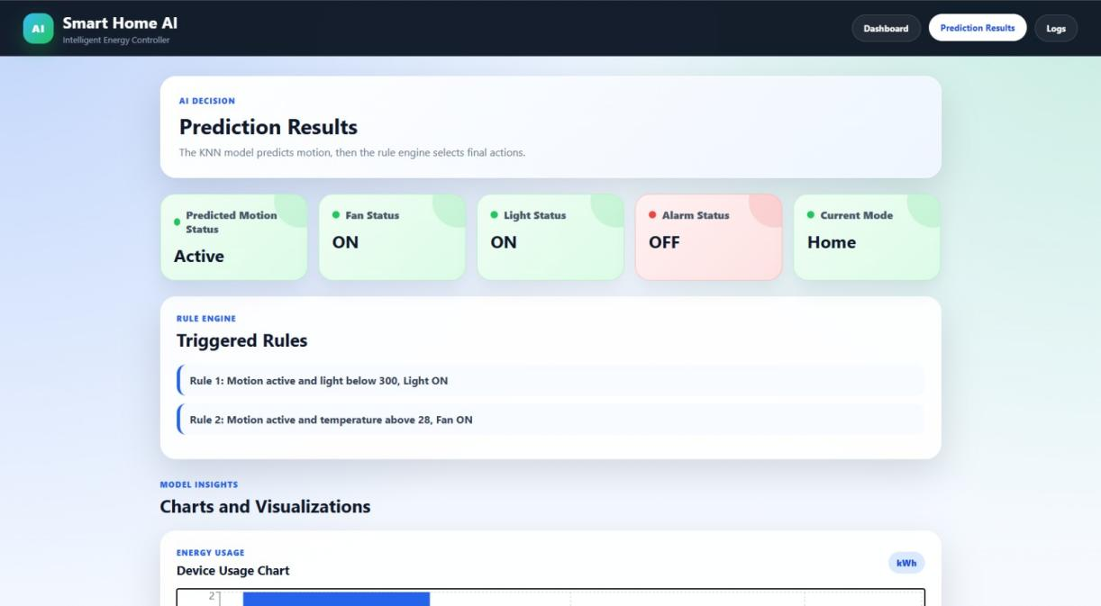

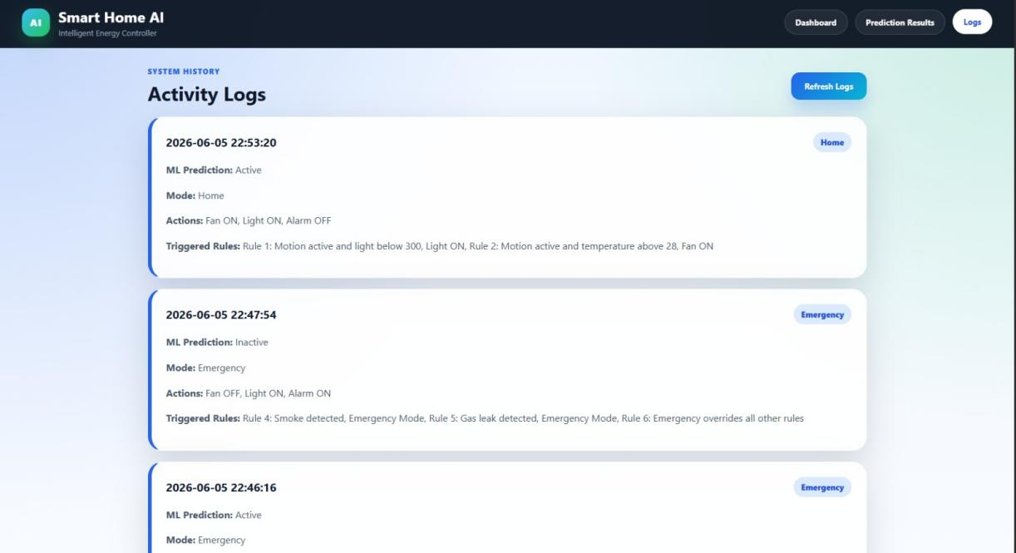

Screenshot 4: Graphs
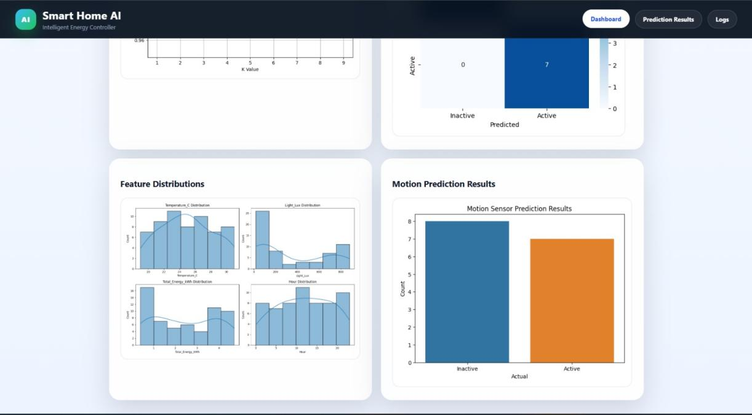

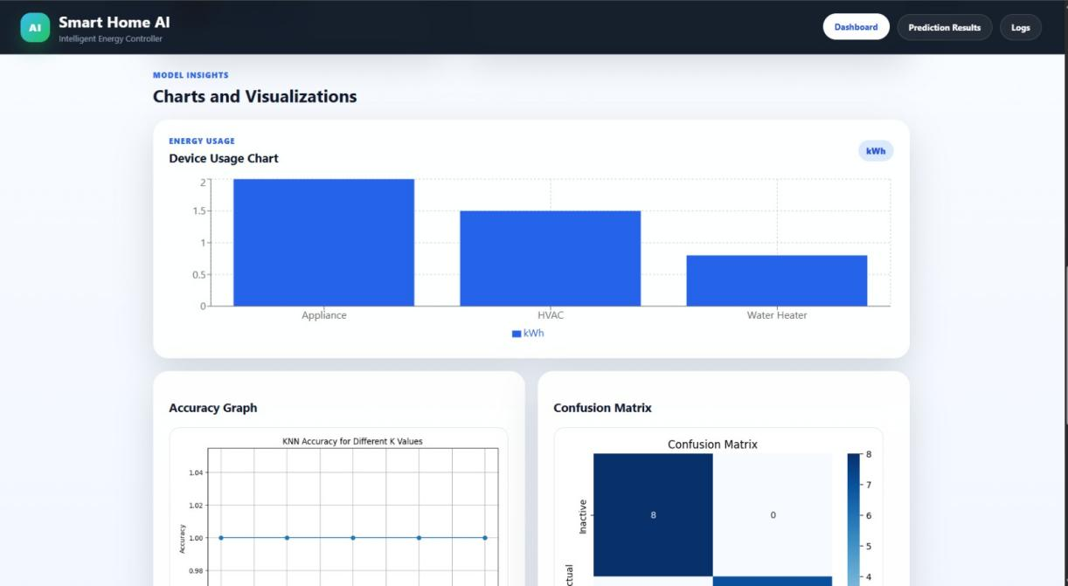

16. CHALLENGES FACED
- Handling missing or inconsistent data
- Balancing dataset for smoke/gas events
- Achieving optimal accuracy for K value
- Integrating model with frontend interface

17. FUTURE ENHANCEMENTS
- IoT device integration
- Real-time sensor connectivity
- Cloud deployment
- Deep learning model integration
- Mobile application support

18. CONCLUSION
This project successfully demonstrates the implementation of a machine learning-based Smart Home Emergency Detection System using the K-Nearest Neighbors algorithm. The system is capable of identifying emergency situations and analyzing energy usage efficiently.
The project enhances understanding of machine learning concepts and their real-world applications in smart home automation systems.

19. REFERENCES
- Scikit-learn Documentation
- Python Official Documentation
- Kaggle Datasets
- Artificial Intelligence: A Modern Approach – Russell & Norvig
- Research papers on Smart Home Automation Systems

20. APPENDIX

Includes:
- Source code
- Dataset samples
- Screenshots
- Configuration files
- Commands used

